G. Surendhra kumar(192524310)

SET 3 – Employee Performance Analysis
Dataset
- Employee ID
- Department
- Years of Service
- Performance Score

Procedure for Importing the Dataset
- Open Tableau Public.
- Click Microsoft Excel under Connect.
- Browse and select the Employee dataset.
- Click Open.
- Drag the worksheet to the canvas.
- Click Sheet 1 to start creating charts.

Task 1: Line Chart
Objective
To visualize employee performance scores.
Procedure
- Rename Sheet 1 as Line Chart.
- Drag Employee ID to the Columns shelf.
- Drag Performance Score to the Rows shelf.
- In the Marks card, change Automatic to Line.
- Click Label and enable Show Mark Labels.
- Rename the chart title to Performance Score by Employee ID.
- Format the axes if required.

Task 2: Bar Chart
Objective
To compare employee performance among departments.
Procedure
- Click New Worksheet.
- Rename it as Bar Chart.
- Drag Department to Columns.
- Drag Performance Score to Rows.
- Change SUM to AVG if required.
- Select Bar from the Marks card.
- Show labels.
- Rename the chart title to Average Performance by Department.

Task 3: Scatter Plot
Objective
To study the relationship between Years of Service and Performance Score.
Procedure
- Create a New Worksheet.
- Rename it as Scatter Plot.
- Drag Years of Service to Columns.
- Drag Performance Score to Rows.
- Select Circle in the Marks card.
- Drag Employee ID to Label.
- Drag Department to Color (optional).
- Rename the chart title.

Task 4: Dashboard
Objective
To combine the Line Chart and Bar Chart into one interactive dashboard.
Procedure
- Click New Dashboard.
- Set Size = Automatic.
- Drag Line Chart into the dashboard.
- Drag Bar Chart beside or below it.
- Click the drop-down arrow on the Line Chart.
- Select Use as Filter.
- Rename the dashboard as:
Employee Performance Dashboard

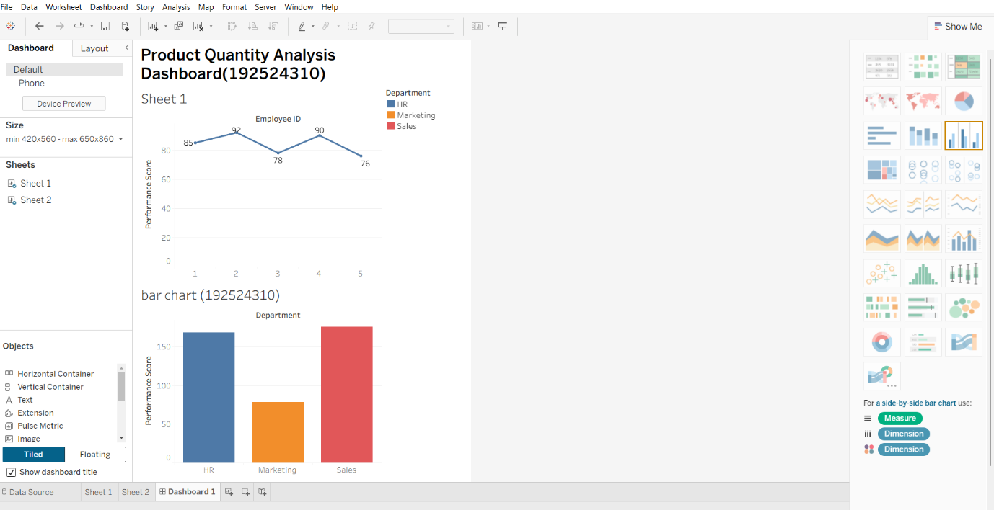
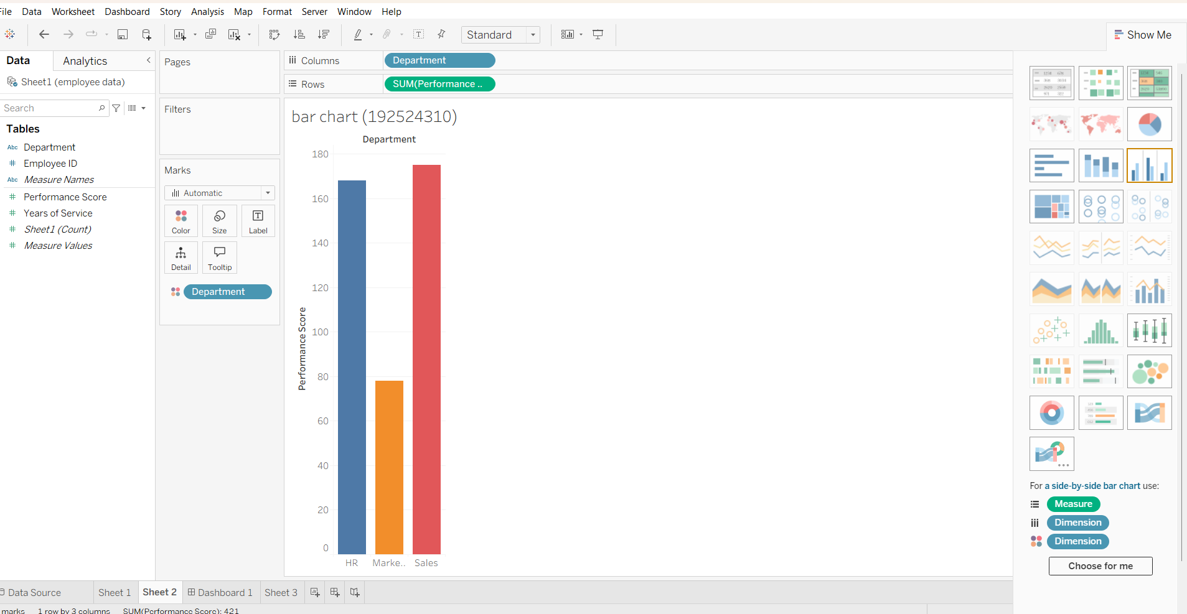

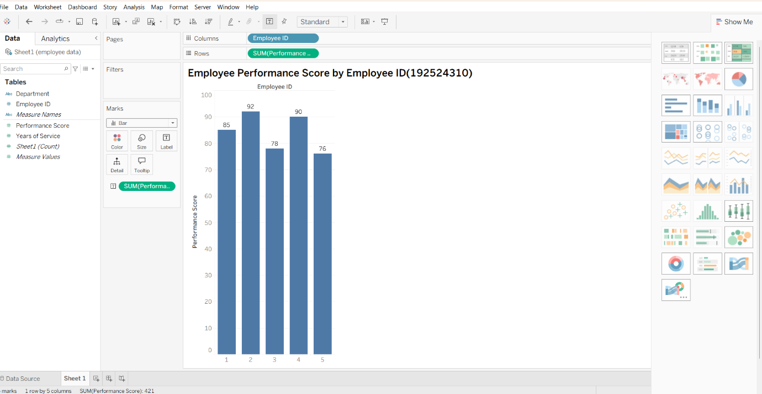
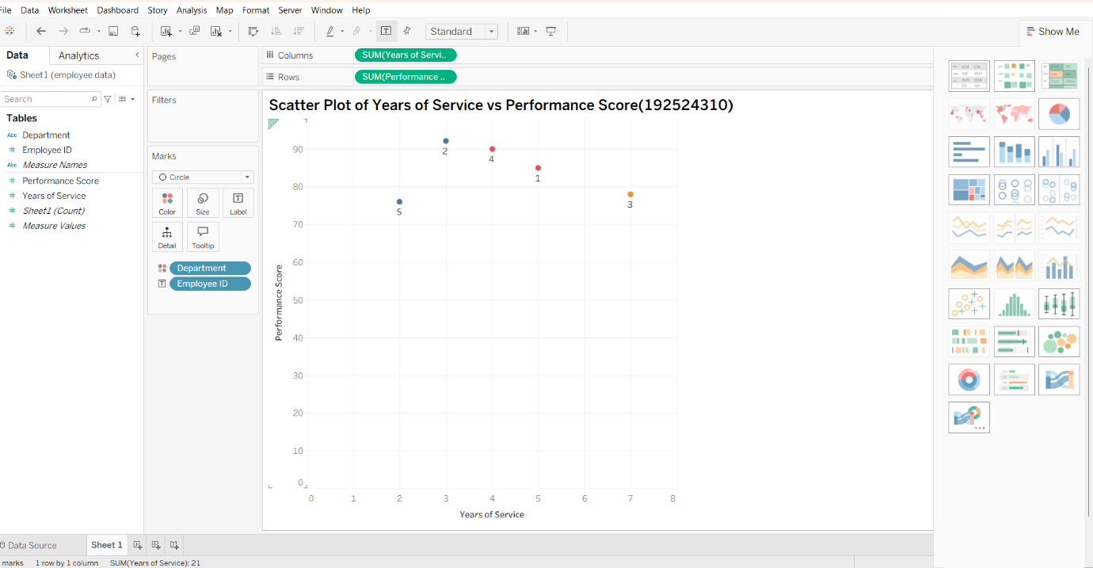
SET 4 – Product Inventory Management
Dataset
- Product ID
- Product Name
- Quantity Available

Procedure for Importing Dataset
- Open Tableau Public.
- Click Microsoft Excel.
- Select the Product Inventory Excel file.
- Open the file.
- Drag the worksheet to the canvas.
- Click Sheet 1.

Task 1: Bar Chart
Objective
To compare the available quantity of each product.
Procedure
- Rename Sheet 1 as Bar Chart.
- Drag Product Name to Columns.
- Drag Quantity Available to Rows.
- Choose Bar in the Marks card.
- Enable Show Mark Labels.
- Rename the title to:
Quantity Available by Product

Task 2: Stacked Bar Chart
Note: A stacked bar chart requires a Category field. If your dataset only has Product ID, Product Name, and Quantity Available, you must first add a Category column in Excel.
Example:
Product Name | Category
Product A | Electronics
Product B | Electronics
Product C | Furniture
Product D | Furniture
Product E | Accessories
Procedure
- Create a New Worksheet.
- Rename it as Stacked Bar Chart.
- Drag Category to Columns.
- Drag Quantity Available to Rows.
- Drag Product Name to Color.
- Select Bar.
- Go to Analysis → Stack Marks → On.
- Rename the chart.

Task 3: Scatter Plot
Note: A scatter plot requires two numeric fields. Your given dataset contains only one numeric field (Quantity Available). Therefore, you must add another numeric column such as Product Price in Excel.
Example:
Product Name | Product Price
Product A | 1200
Product B | 900
Product C | 1500
Product D | 1100
Product E | 700
Procedure
- Create a New Worksheet.
- Rename it as Scatter Plot.
- Drag Product Price to Columns.
- Drag Quantity Available to Rows.
- Select Circle.
- Drag Product Name to Label.
- Rename the chart.

Task 4: Dashboard
Objective
To combine the Bar Chart and Stacked Bar Chart.
Procedure
- Click New Dashboard.
- Select Automatic size.
- Drag the Bar Chart into the dashboard.
- Drag the Stacked Bar Chart beside it.
- Click the drop-down arrow on the Bar Chart.
- Select Use as Filter.
- Rename the dashboard as:
Product Inventory Management Dashboard

Common Steps for Every Tableau Practical
- Open Tableau Public.
- Connect to the Excel dataset.
- Drag the worksheet to the Data Source page.
- Open a worksheet.
- Create the required charts.
- Add labels and titles.
- Create a dashboard.
- Arrange the charts neatly.
- Enable Use as Filter to make the dashboard interactive.
- Save the workbook and publish it if required.
Important Note for Set 4
With only these columns:
- Product ID
- Product Name
- Quantity Available
you can create a Bar Chart, but you cannot correctly create:
- Stacked Bar Chart (requires a Category field)
- Scatter Plot (requires a second numeric field such as Product Price)

